Downloading and Uploading files with Dreamweaver (FTP)

To use FTP via Dreamweaver

Step 1: Start Dreamweaver. Click ASP.NET C#

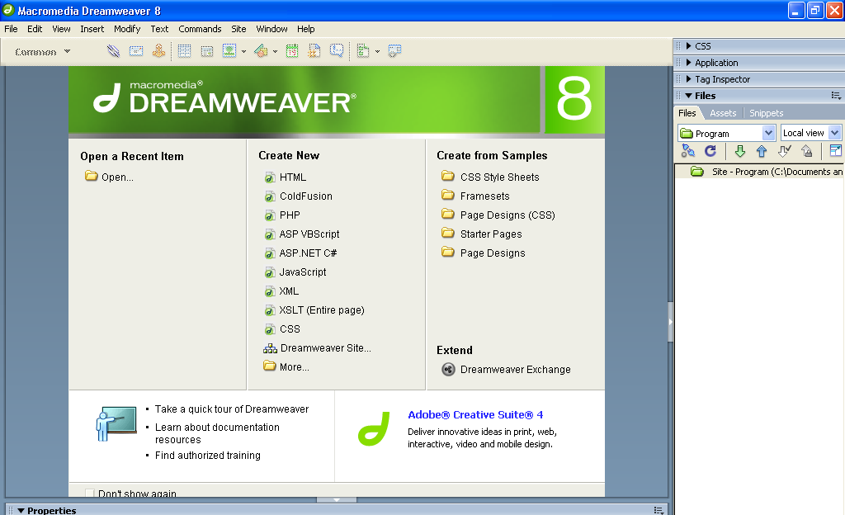
Step 2 :Choose Manage sites… under site menu

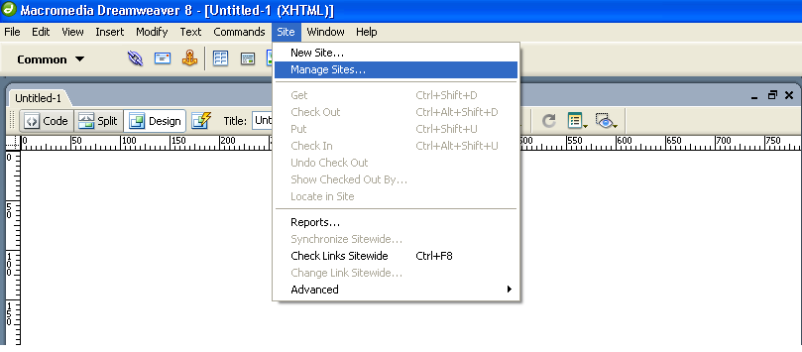
Step 3 : After clicking manage sites the popup will display and here click New - >Site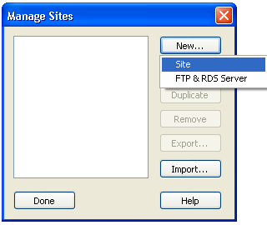
Step4 : Making sure you have the "advanced" tab selected, enter a name in the "Site name" box. This can be any name of your choosing. In the "Local root folder" box navigate to the folder on your local computer or network where you are storing your files for this Web site.

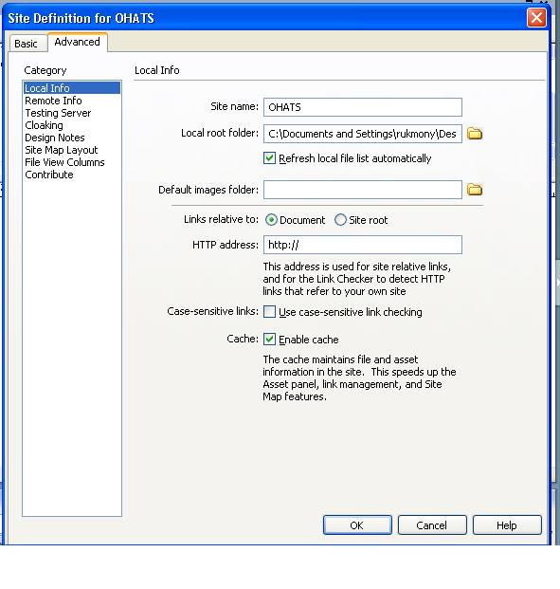

Step 4 : click Remote info and choose FTP from Access drop down
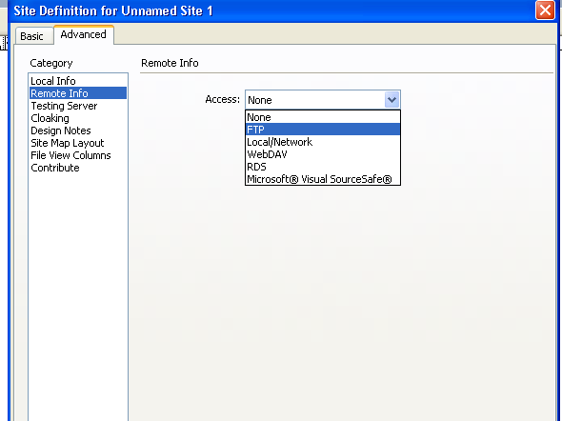

Step 5:After choosing FTP from the drop down enter the ftp information(E.g I entered OHATS file location )
On FTP Host : vattsystems.com
Login : tutormentor
Password : Tutor2009
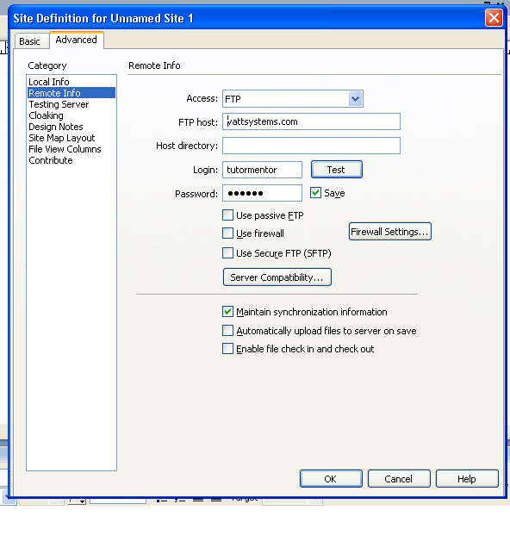
Step 6 :Click OK button

After that popup will be shown as with created site name
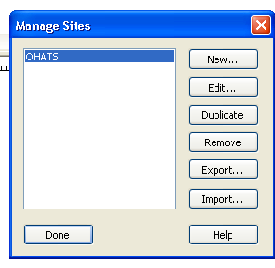
Step 7: Click Done
Right pane details
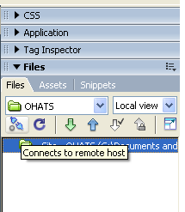
Upload(Put files)
Download (Get Files)
Connect
Expand / Collapse

Step 8 : In right pane , click Connect
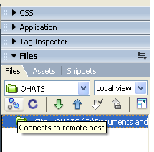
Step 9 :Choose Remote view from the dropdown as shown
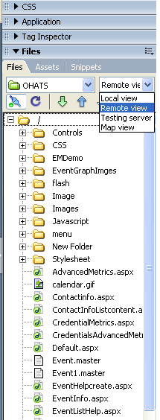

Step 10 :We can able to view the remote server files. To download the remote files on your local site means. Select the file and click Download button(Get files) on right pane
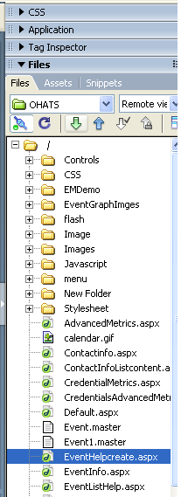
Now selected files moved to our newly created site
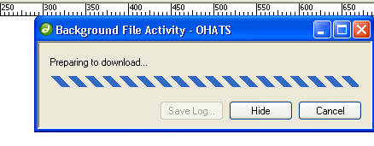
Step 11: Click “No” on the following popup
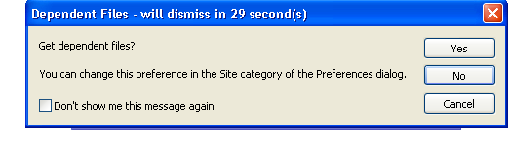
Step 12 : Then the selected file(Event help create downloading is in progress)
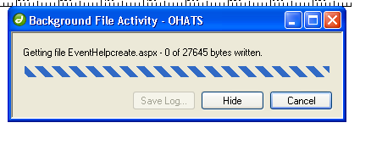
Step 13 :Check the local folder where the file is downloaded by choosing Local view
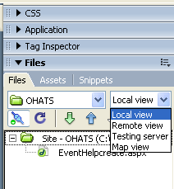

Step 14 : We can view the downloaded files on your site, Double click Eventhelpcreate.aspx page to edit
You have downloaded the file to your local drive.
Make sure code is selected, To view the design click Design
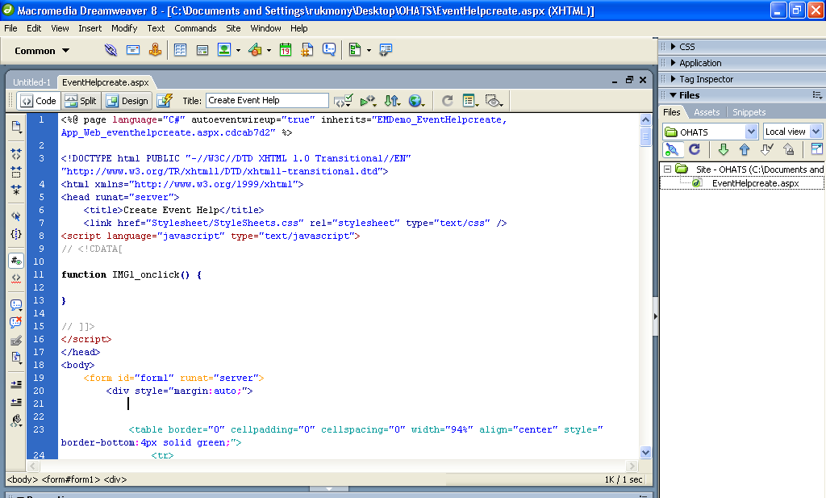
STEP15: Find the text you want to change – By clicking EDIT (menu) and FIND the text.
STEP16: Make changes and after the editing, to save the changes - click SAVE button
Step 17 : To upload the file on server
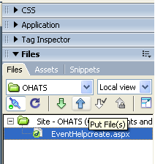
Upload (Put files)
Now the selected files will be uploaded on the server with the changes we made

